**Voting App with Docker**

**Project:** 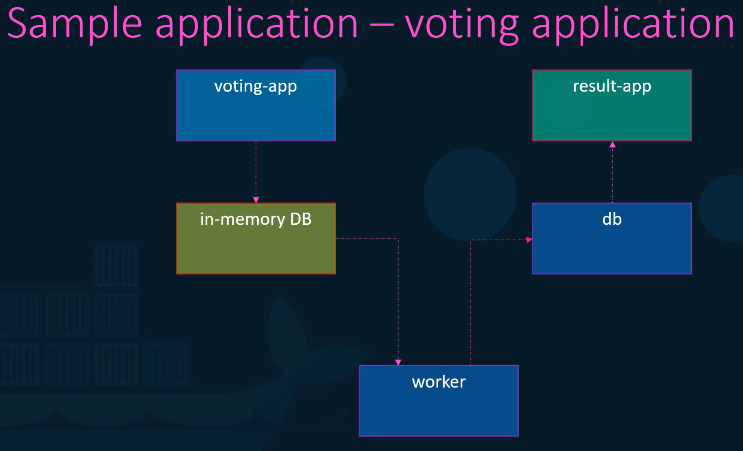

In this project, lets familiarize with the application. It is a sample voting application provides an interface for user to voeet and another interface to show the results. The application consists of various components such as voting-app developed in python which provides user an interface to choose between two options cat and dog. 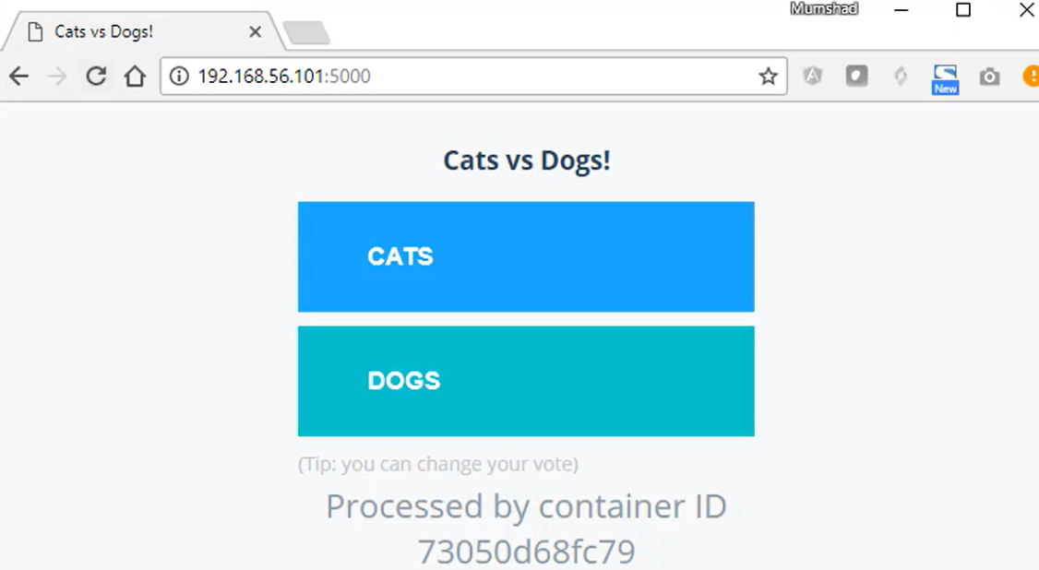

Once, user selects the option, it will stored in redis, which serves as databse in memory. This vote is then process by the worker which is application written in ‘.Net’.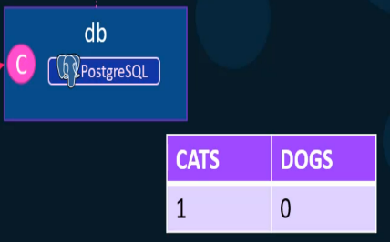 This worker application takes the new vote and updates the persistent database which is PostgreSQL. This db will simple have a table with the number of votes for each category. It increases the number of votes for cats or dogs. Finally, the result of the votes is displayed in a web application which is another application developed in Node-JS. This app reads the count of votes from PostgreSQl db and displays it to the user. So, this is the architecture of the app.

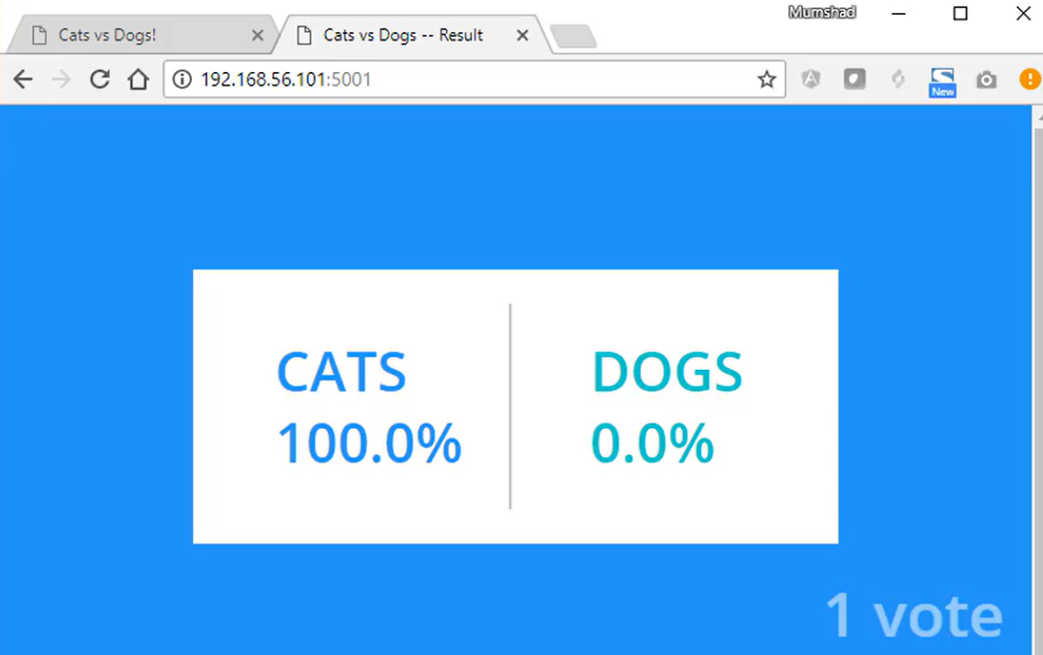

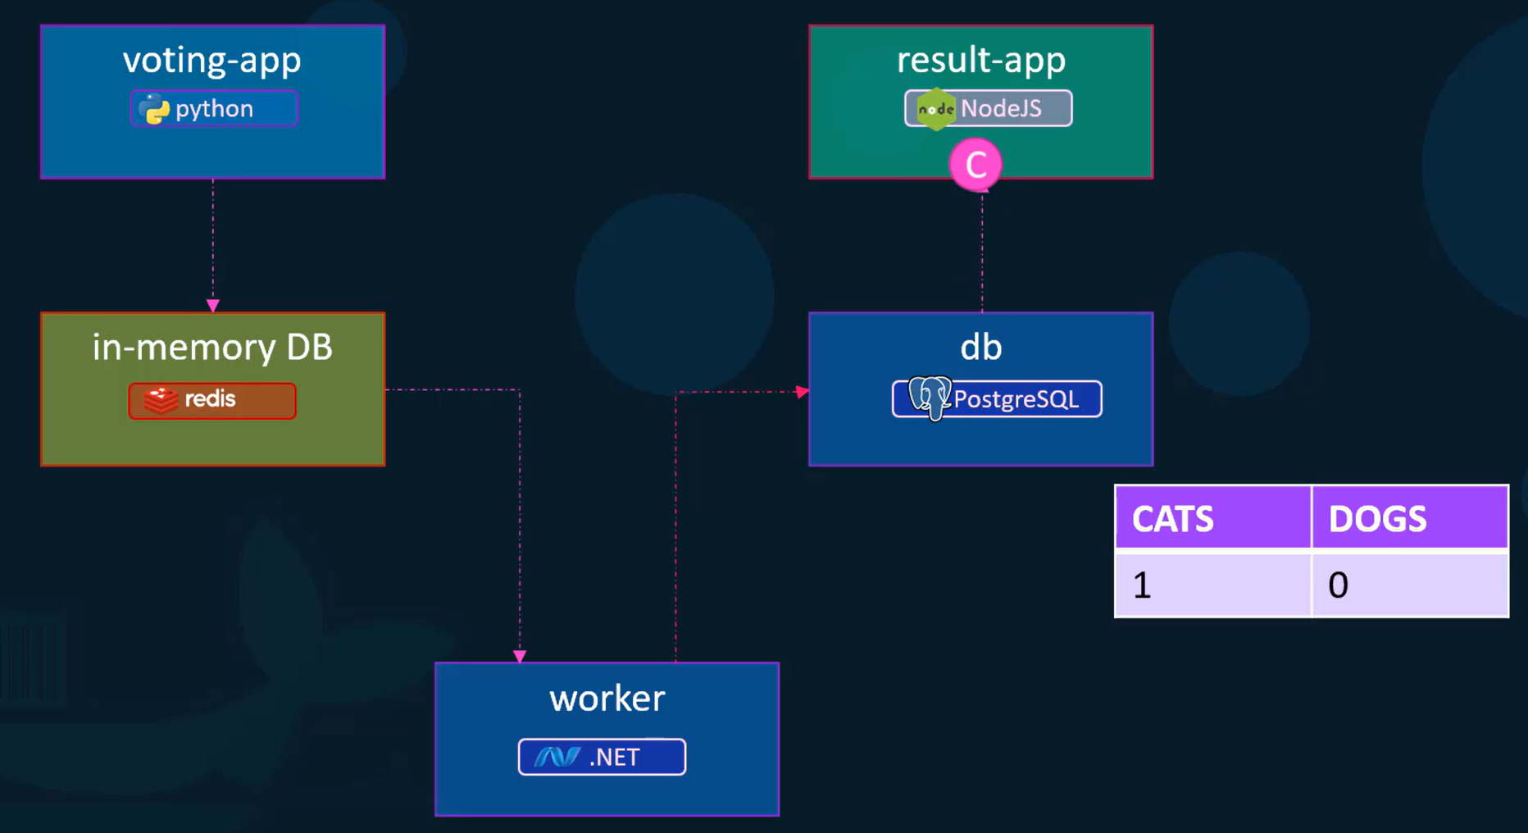

GitHub Repo: <https://github.com/mntforever/docker-samples-voting-app>

This repo is cloned from <https://github.com/dockersamples/example-voting-app> but this is updated with Docker swarm and K8’s.

Can use first repo where cloned version is not updated with.

**Pre-requisite:** Create an Ubuntu EC2 instance and install docker in it. Then, you can clone the repo. 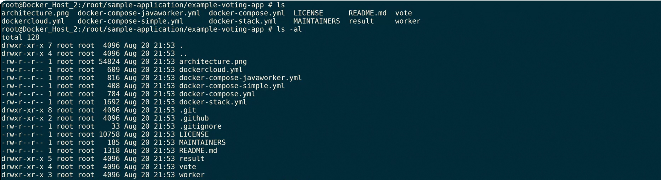 Let’s go with vote application first. Change directory to vote and see Dockerfile. 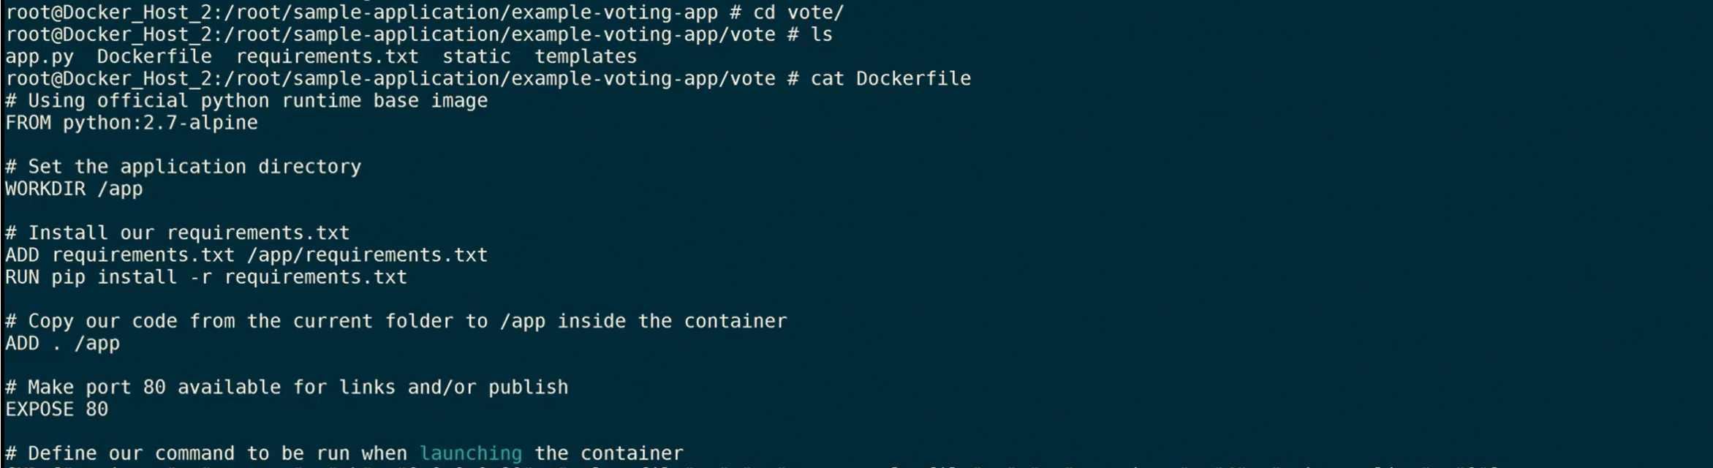We will build the docker image by running the docker build command and we will tag with name **voting-app** using below command.

Command: **docker build . -t voting-app**  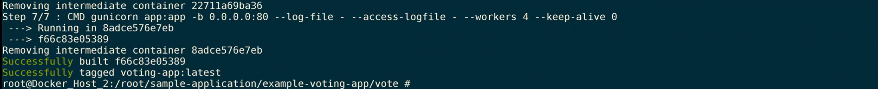Now, we have voting-app image and we will run the image and make it avaibale on port 5000 in host as it is running on port 80 inside the container. 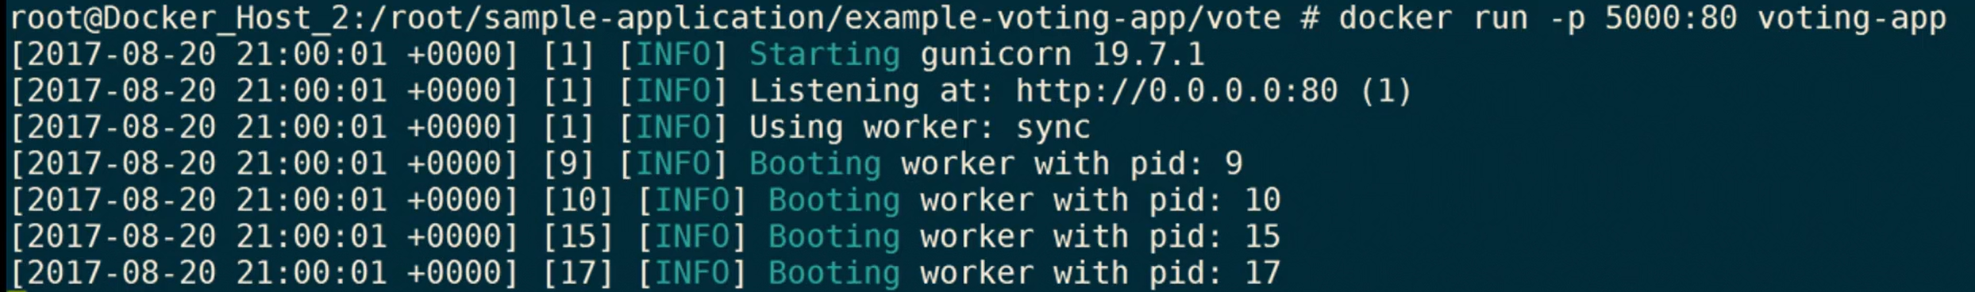 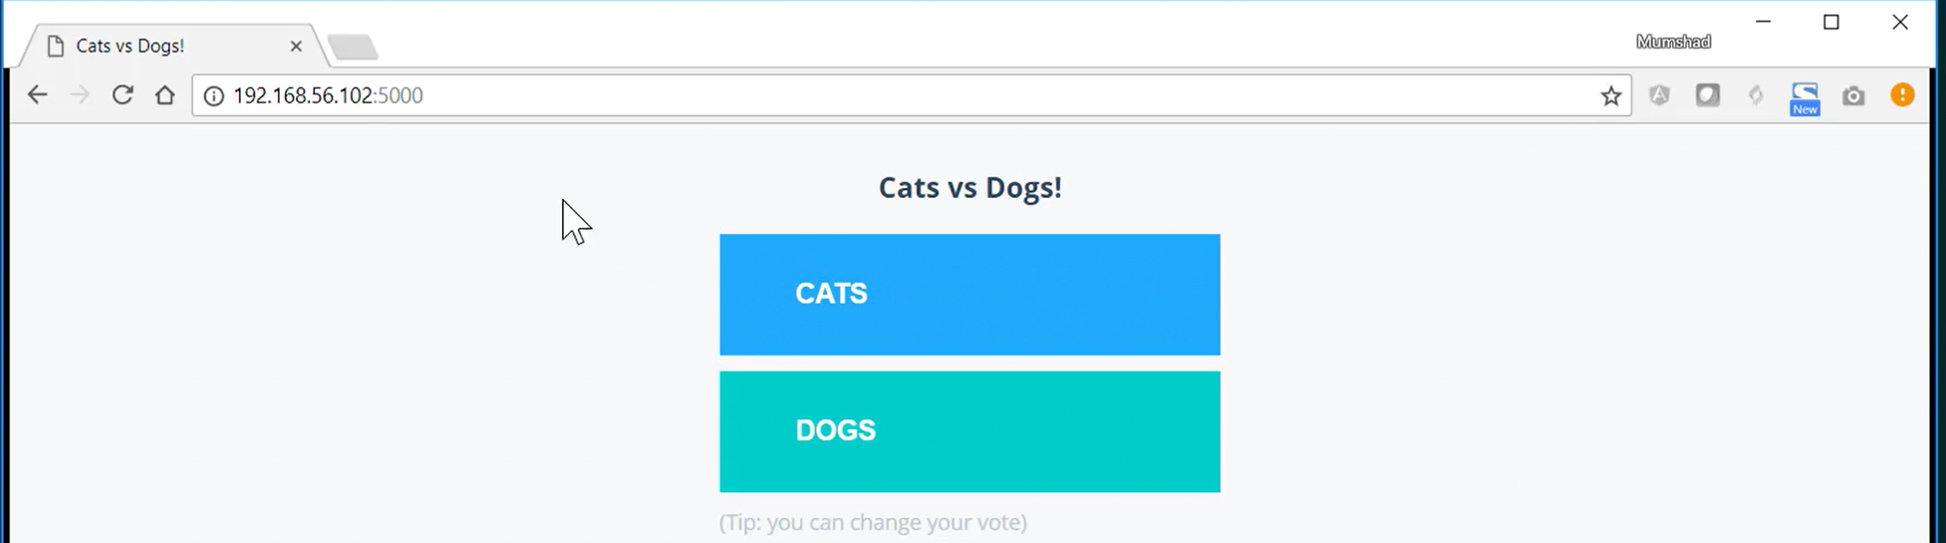Now, if you try to caste your vote by clickong on of the button. It throws error. 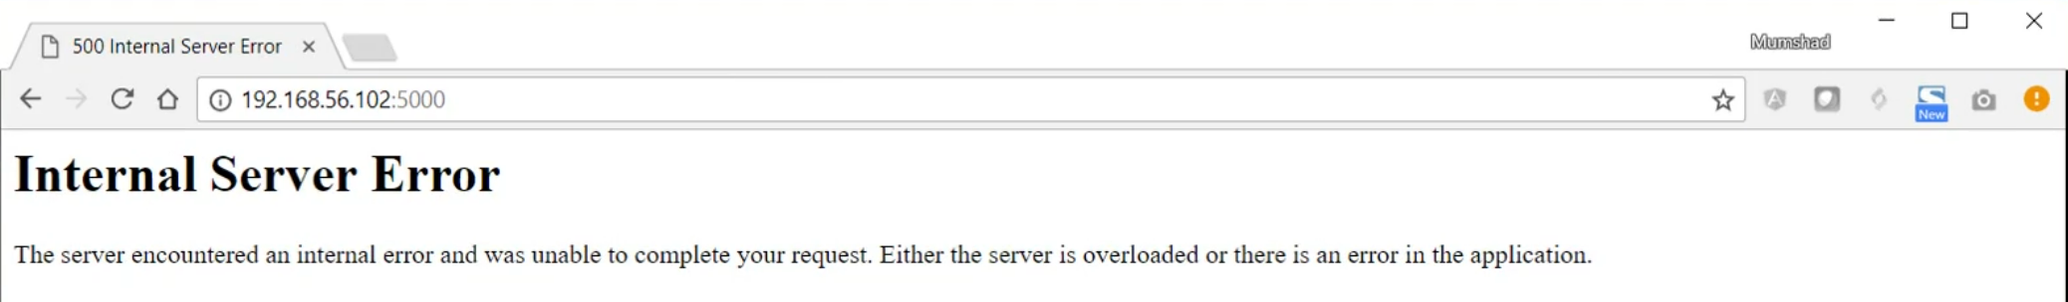You can also check the logs, 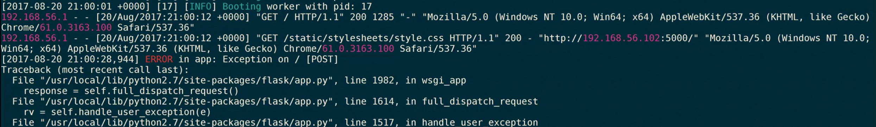these logs are visible for all the actions you perfomr in the browser on the application. Once you run the docker run command. It will be inside that conatiner and shows us logs.

We will stop this conatiner and run some **redis** conatiner.  

Now, we will run the voting app again using docker run command by adding link to the redis as well.Lets try to vote for cats or dogs. It will work. 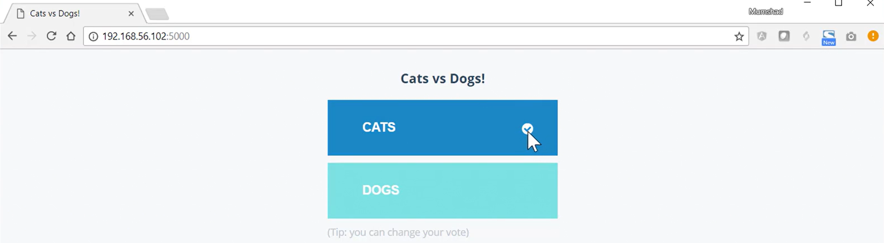It goes successfully and I get tick mark. By now, we had deployed voting-app and redis. We will now proceed with worker application. And for this postgres db is the pre-requisite. 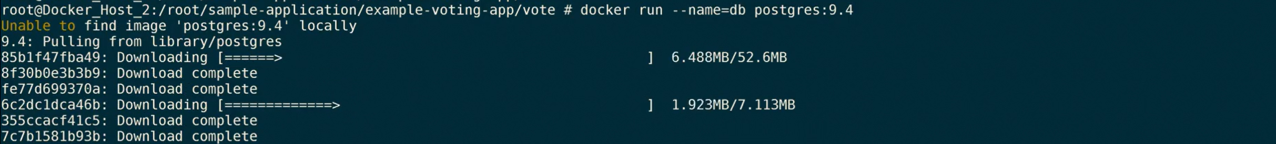They are using version 9.4 you can find that in docker-compase.yaml file. While recording this session they used this version. Current git repo had this version. 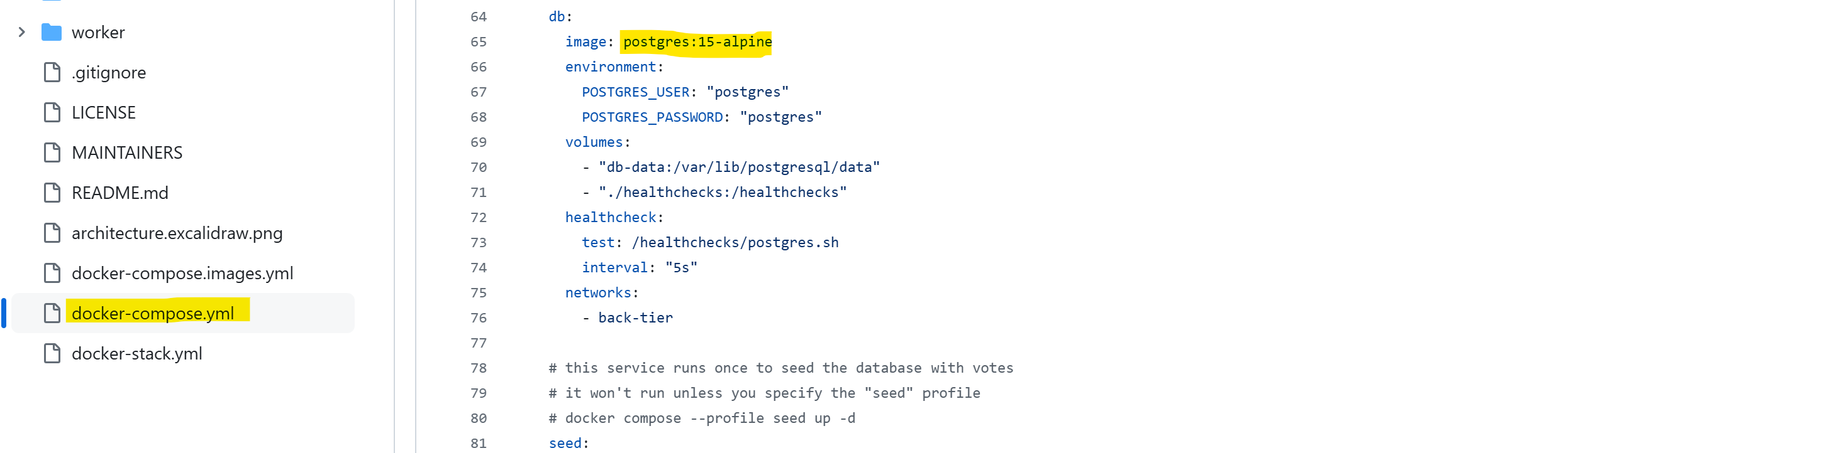We forgot to run the conatiner in the background lest cancel that and try to run again in background. It is failing because there is already a conatiner with that name. So, we have to remove the prevoous one first and then run in background again. We now have the postgres db running. Let’s deploy the worker application. Go to worker directory and build the image using docker file.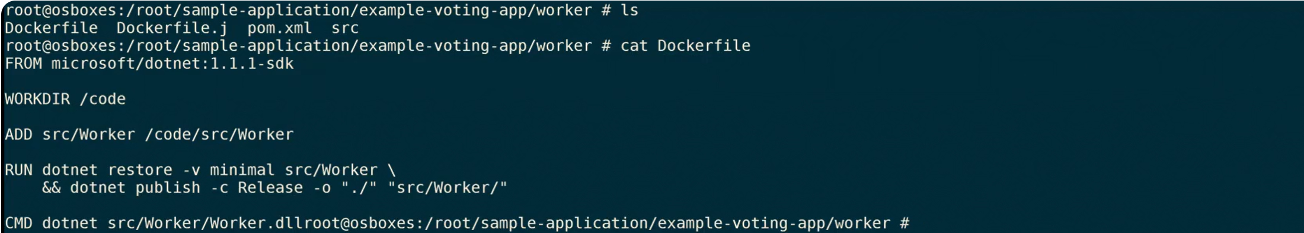 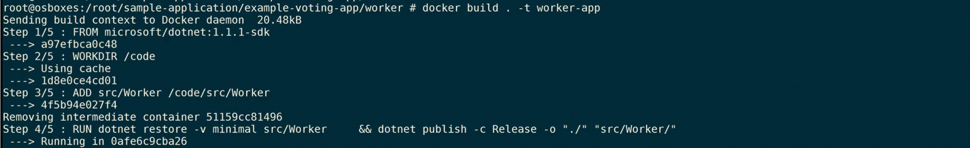 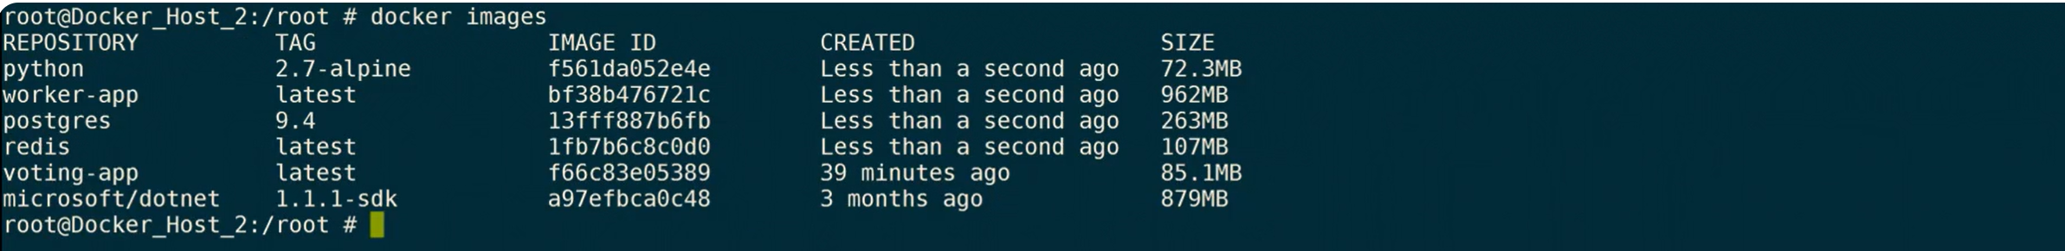

Worker application needs link to two db – redi sand postgres. Also, it processes the previous vote that we casted earlier.Now, run **docker ps** there are four conatiners running. Now, last step is to build and deploy the result app and link it to the postgres db. Go to result folder. 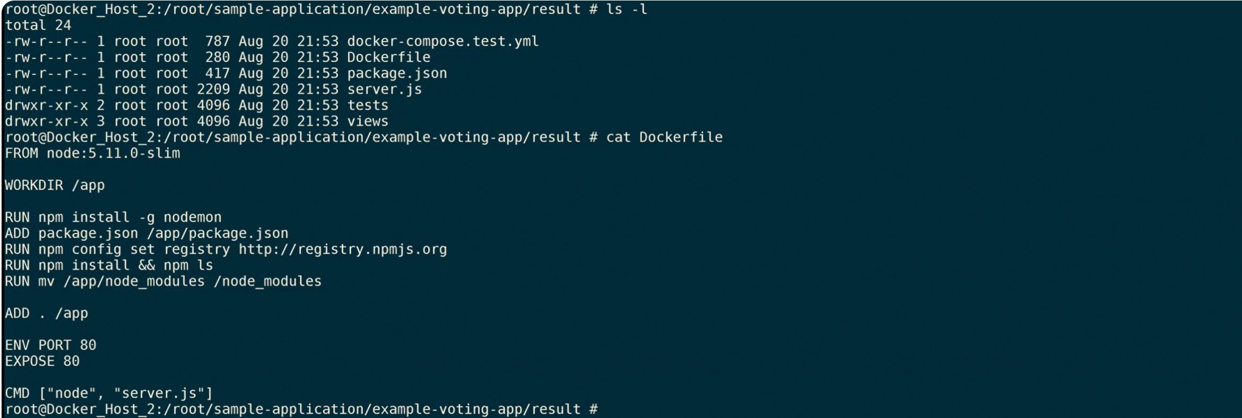 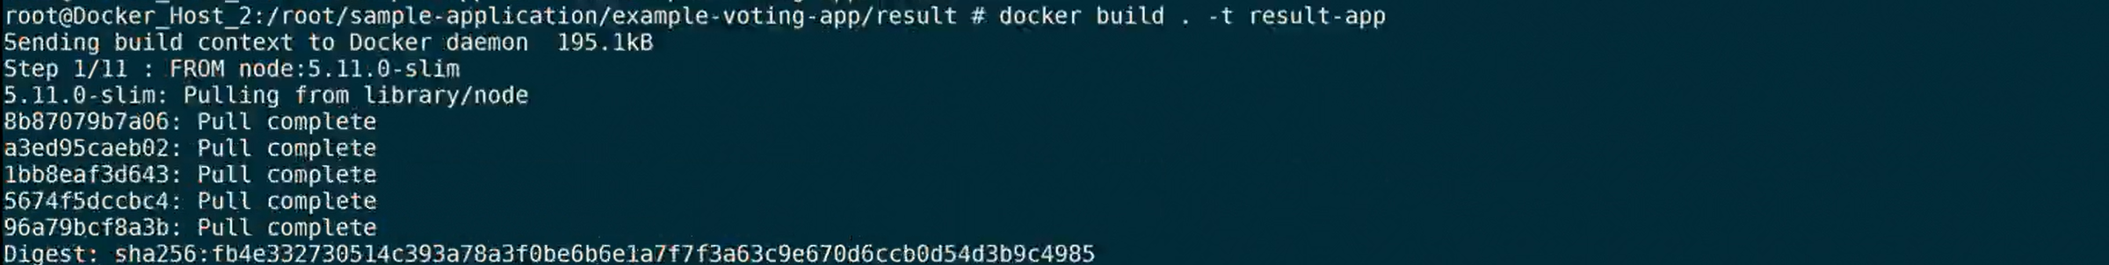 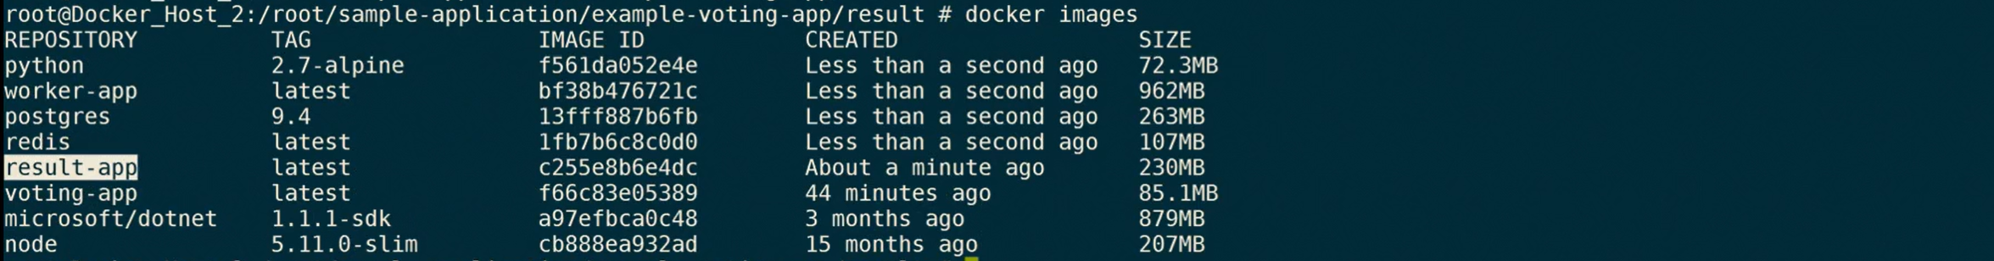 In New tab, go to post 5001, to see the results: 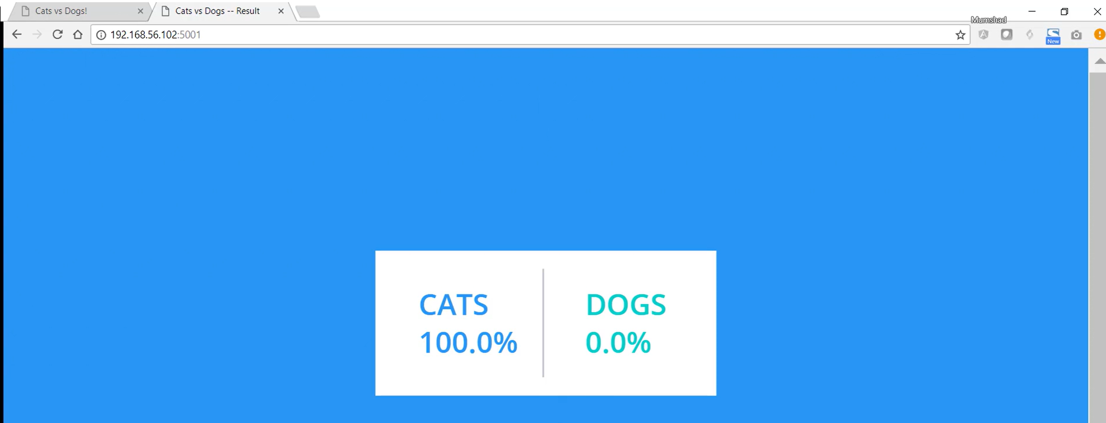We can go back and change the vote. And results will be updated here. 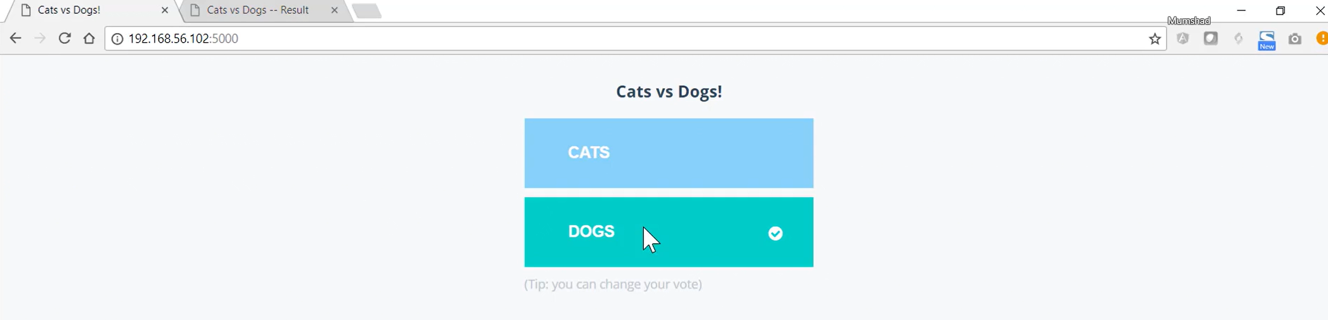

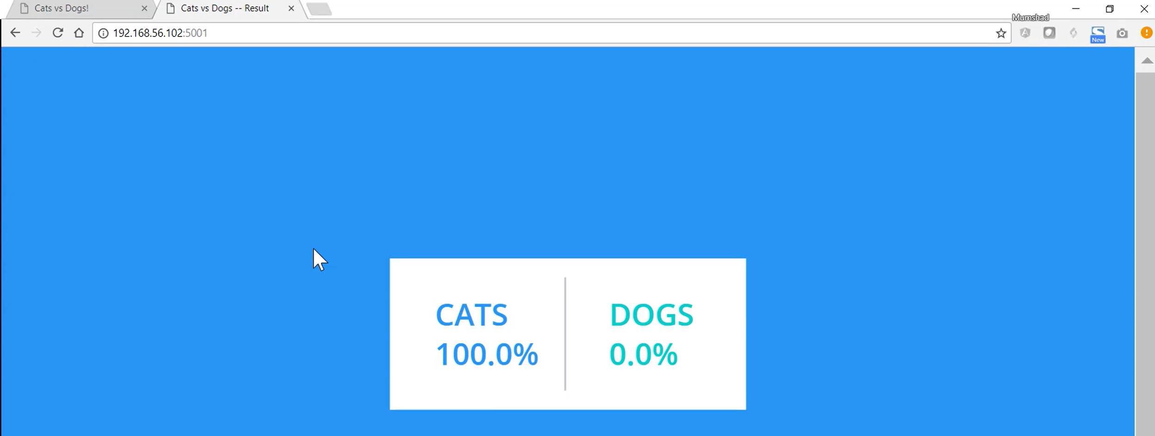Every time we change the vote it goes through the same cycle from beginning.

**Voting App with Docker Compose**

**Project:**

We are using the same app but deploying app with docker compose. We have to install Docker compose separately.

**URL:** <https://docs.docker.com/compose/install/standalone/>

**Commands:**

curl -SL https://github.com/docker/compose/releases/download/v2.27.1/docker-compose-linux-x86_64 -o /usr/local/bin/docker-compose 🡪 chmod +x /usr/local/bin/docker-compose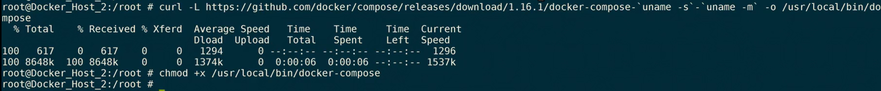Since we are using the same machine, first we have to clean up. Stop all the running conatiners by specifying the first two digits of the conatiner. 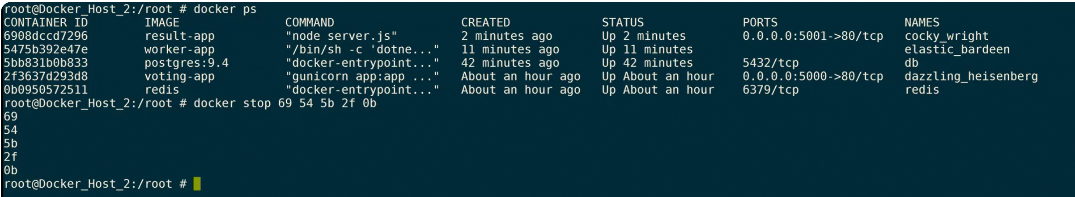 We now create a docker compose file and write the yaml file. Write same code in the docker-compose yaml file you created now.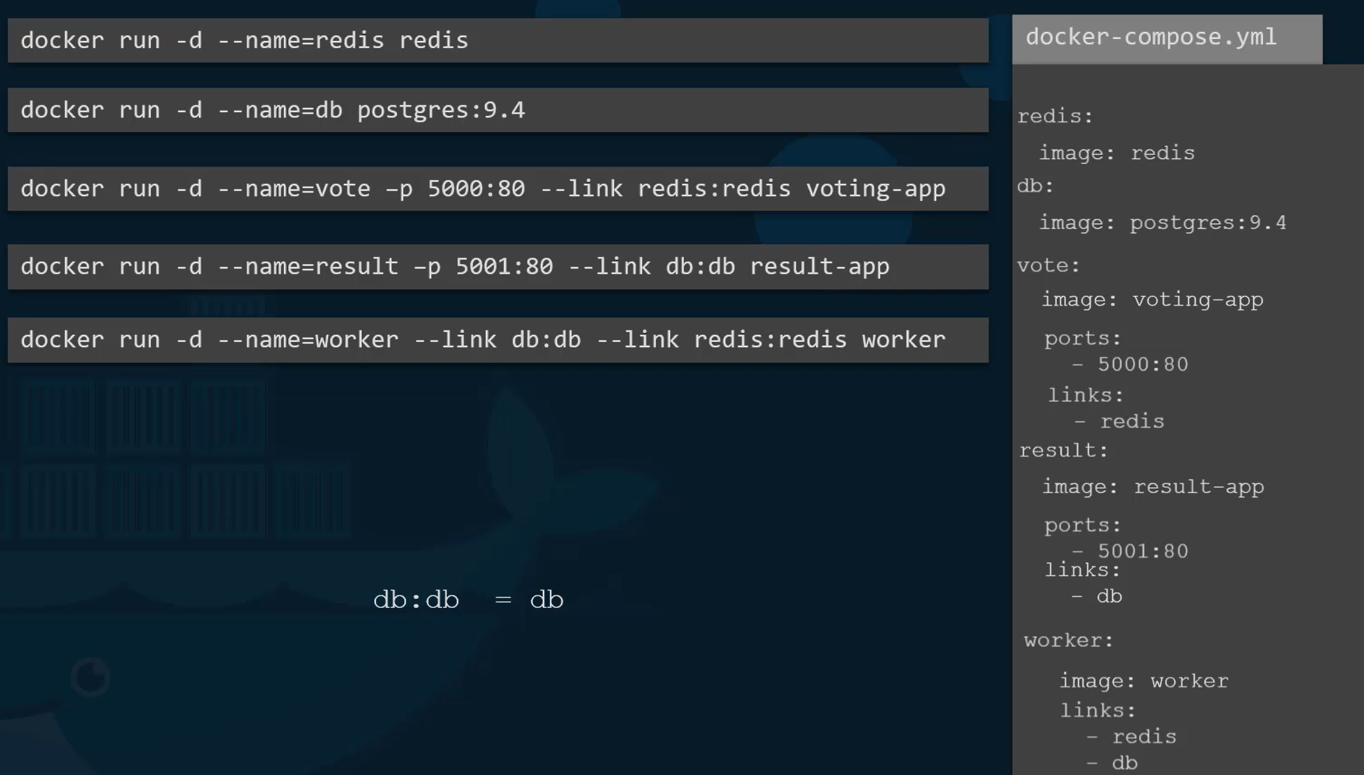Save this file and then run the docker-compose run command.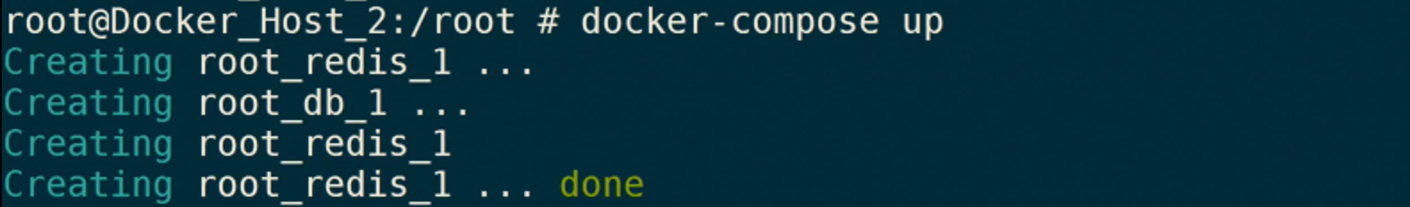 You can access the application as it is up and running now.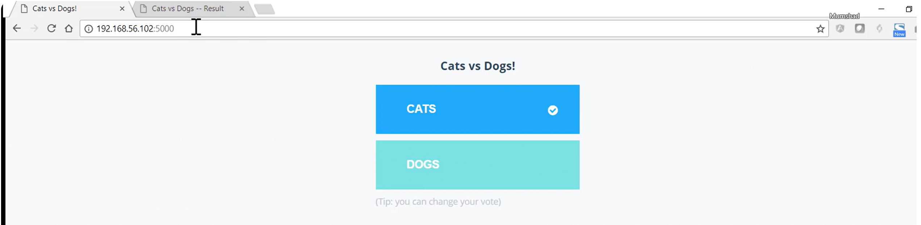 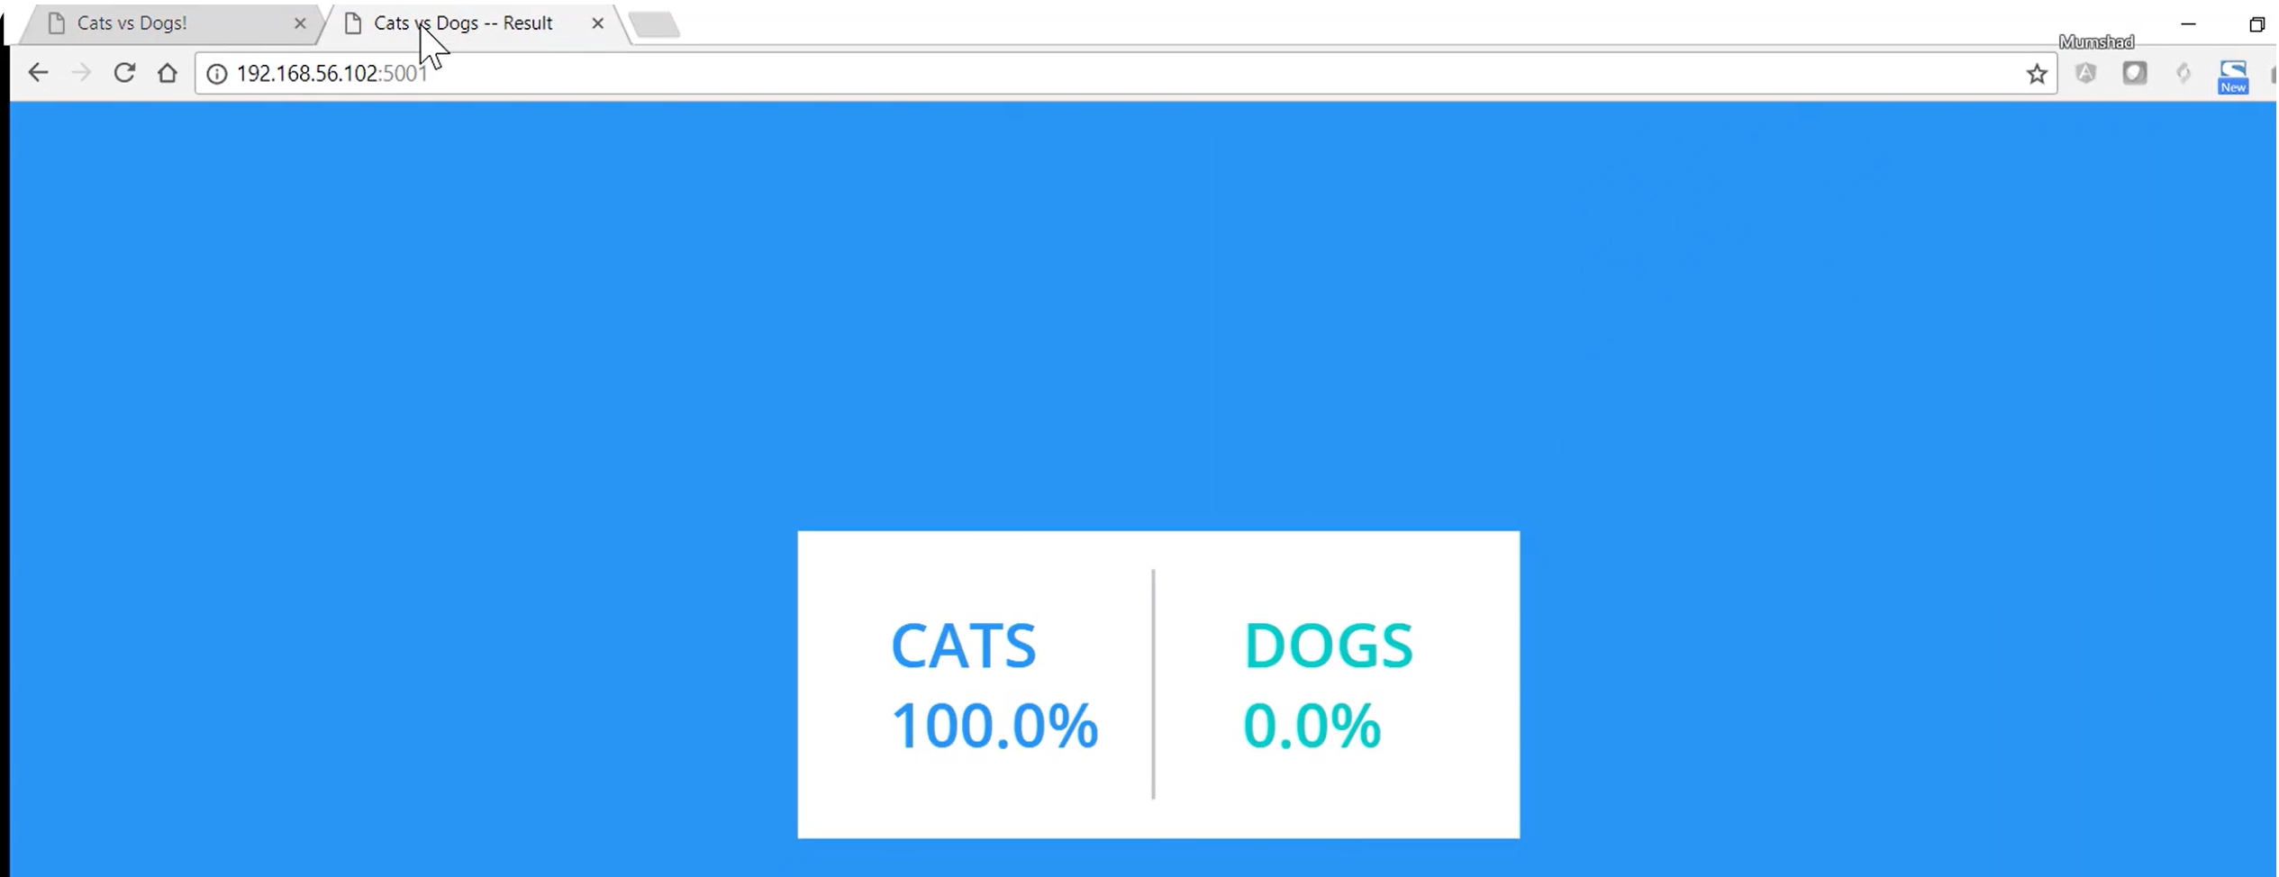

**Improving Docker-Compose file**

**URL:** <https://docs.docker.com/compose/compose-file/build/>

We can update the dcoker compose file version using this reference. We can directly convery into particular version

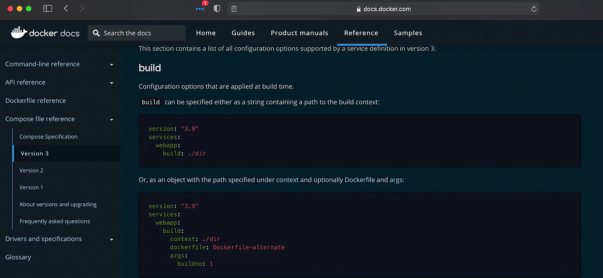

There is a change in postgres db recently and we have to add user and password details otherwise it will fail while giving **docker-compose up** command.

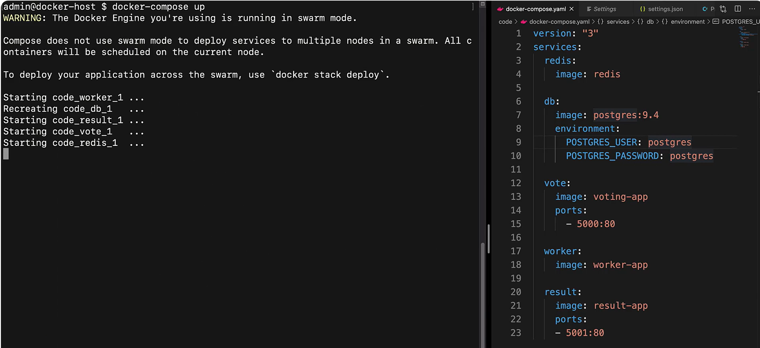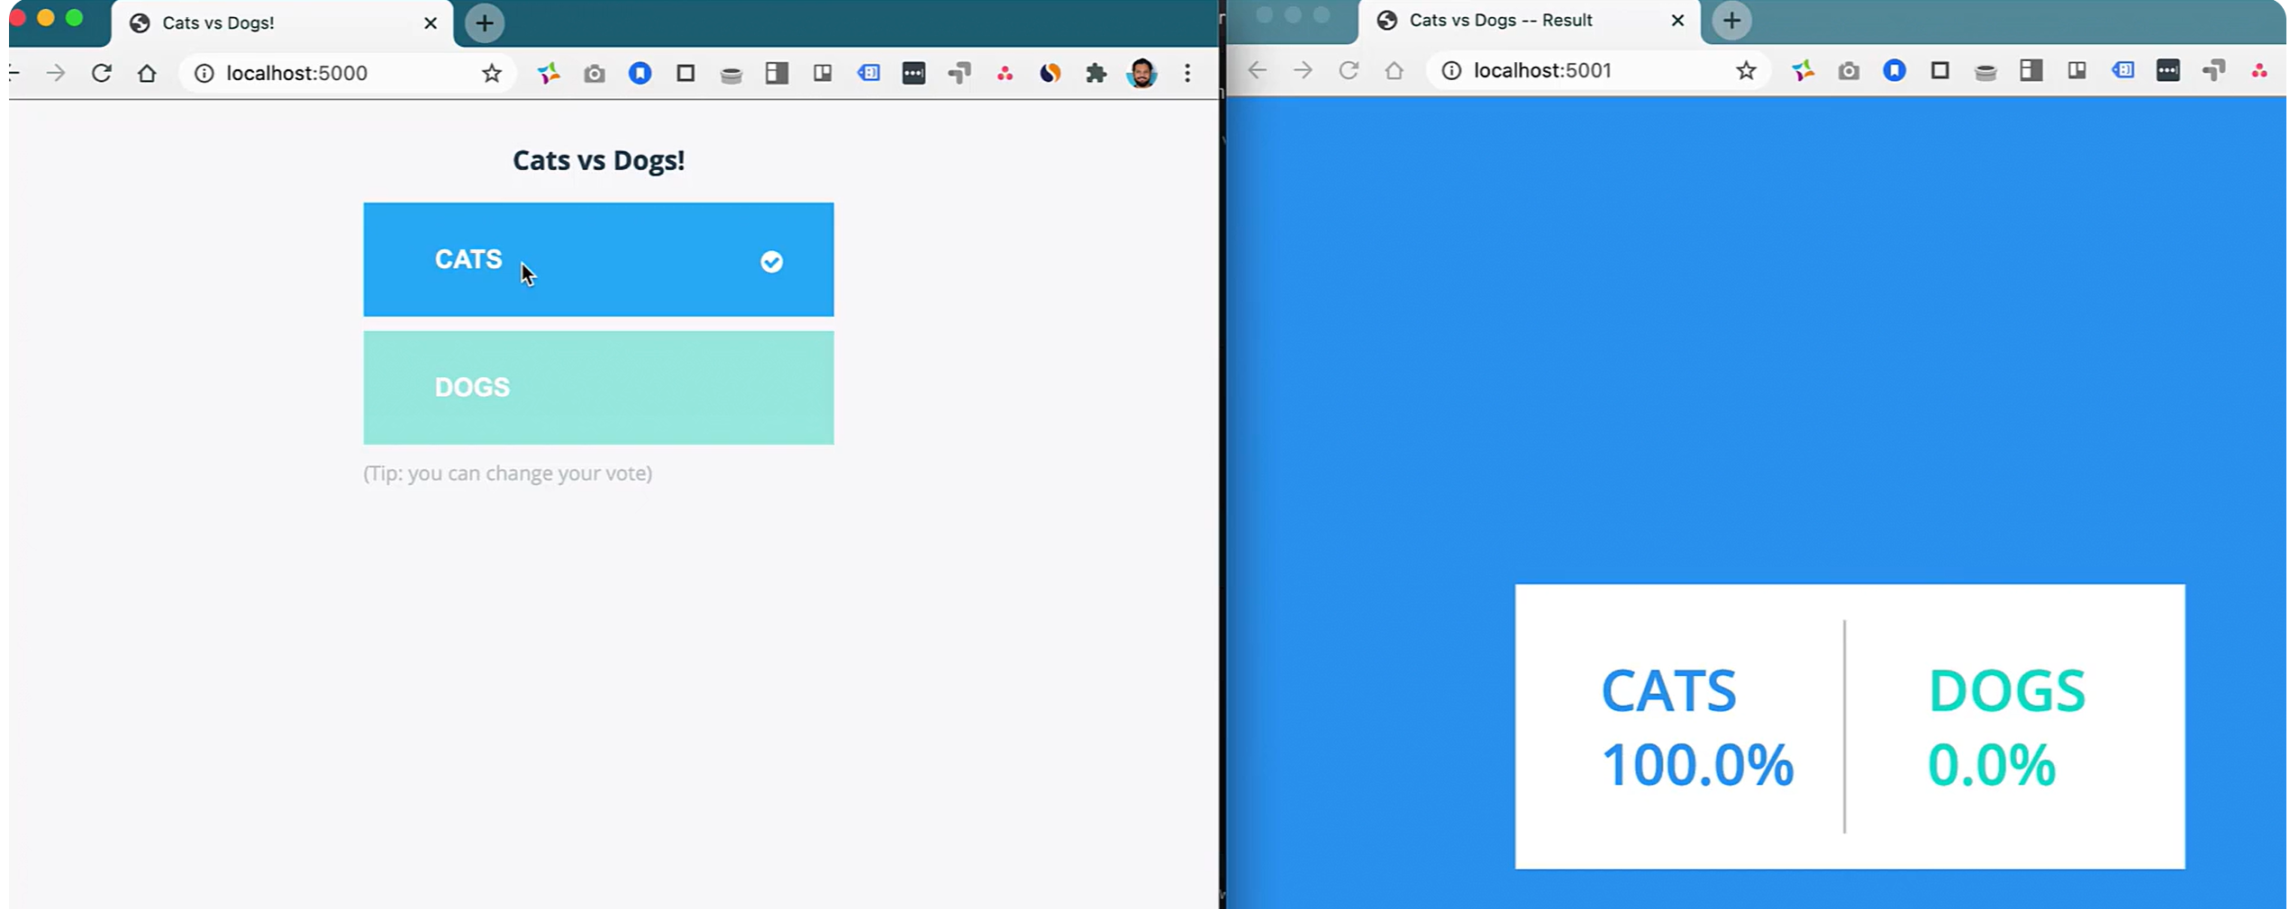

**Refrenece Links:**

<https://docs.docker.com/compose/>

<https://docs.docker.com/reference/cli/docker/compose/>

Latest Voting app with K8: <https://github.com/dockersamples/example-voting-app>

Voting app with docker only: <https://github.com/mntforever/docker-samples-voting-app>